QUESTION | GROUP ANSWERS
How does Girl Guiding/Girl Scouting make you feel?

What does Girl Guiding/Girl Scouting mean to you?

What have you learned in Girl Guiding/Girl Scouting?

What teamwork skills would you like to learn?

What interpersonal skills would you like to learn?

What practical skills would you like to learn?

What personal skills would you like to learn?

What local or global issues/topics would you like to explore further?

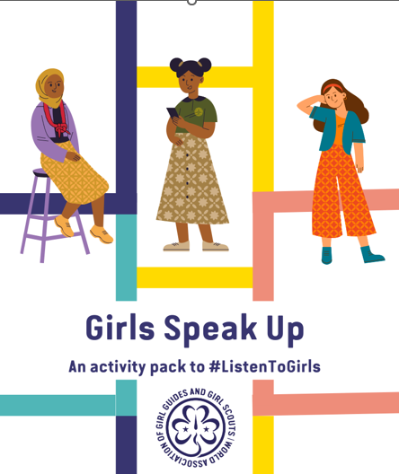
Make sure to submit your Group’s answers to WAGGGS via the webform before November 30th 2022:
#ListenToGirls Youth Consultation International Day of the Girl 2022 (Preview) (office.com)
This sheet is an optional tool for groups to use to record their consultation answers on as you do the activities together.
INTERNATIONAL DAY OF THE GIRL 2022
YOUTH CONSULTATION
GROUP RESPONSES RECORD SHEET

