Guidance Note:
Girls and young women’s participation in ‘Her World, Her Voice’

Who is this guide for?
This guidance note is intended for MOs that plan on contributing to Global Outcome 3 of ‘Her World, Her Voice’; ‘Improved practice of girls and young women’s meaningful participation across the partnership’.
This may be the sole focus of your project, or it may be a component of your project. The following guidance note provides some steps to consider when planning for the meaningful engagement of girls and young women in the planning and delivery of your project.
Why girls and young women’s participation?
A key pillar of the global ‘Her World, Her Voice’ programme is to strengthen girls and young women’s (GYW) participation across WAGGGS programmes, advocacy and across the movement. The Fund seeks to drive promising practice, by funding MO projects that can demonstrate innovative approaches in the meaningful participation of girls.

Steps to consider:

1. Determine where it would be most beneficial and feasible to involve GYW.
Consider where GYW fit best across your project cycle. Whether that’s in the planning the project, implementation or through the evaluation phase. Not every activity in the project can or necessarily needs to involve girls and young women, and it is likely to be a more enriching experience and one that will generate deeper learning and impact, if a targeted approach is taken.
Here are some recent examples from across the Girl Guides and Girl Scouting movement where girls have been meaningfully involved in programming in significant ways.
Programme Design: Badge Co-Creation
Both Girl Powered Nutrition and Surf Smart programmes have utilized a co-creation methodology to partner with girls to develop activity packs and badges.
This ensures that the activities and contents of the activity pack are relevant to the needs of the girls and leaders.
A co-creation team is formed that plays a central role in generating ideas for new activities, testing the activities, collecting feedback and ensuring the materials are accessible and appropriate to the local context and targeted age brackets.
Monitoring, Evaluation and Research:
In Girl Powered Nutrition, a group of young women have been involved in various M&E activities. In the internal and external evaluation, 14 selected young women from Madagascar, the Philippines and Tanzania were trained in data collection methods and tools. They led and facilitated the focus group discussions with their fellow girls and young women and community members. Moreover, 7 young women were also selected to co-facilitate the workshops in the GPN national project reviews, where various stakeholders in their respective countries gathered to celebrate the success and identify lessons learnt from the programme implementation.
In the Motion 32 research project, WAGGGS has employed a participatory research methodology by forming a Young Women Research Team (YWRT) to deliver the research. Supported by the Project Team, the YWRT co-designed the research plan, conducted data collection to various sampling groups at the global and national level, co-analysed the collected data, validated the preliminary results, co-interpreted the findings to come up with recommendations, and disseminated the results through written report and webinars.
Girl-Led Advocacy: Girls as Drivers for Change
A unique partnership formed between WAGGGS and Save the Children in Jordan and Uganda, girls participate in ‘solution labs’ where they are connected with inspiring female leaders, to discuss the change they want to seek and are supported to develop their ideas. From there, girls are then able to apply for grants from a girls’ fund to implement their ideas to reduce GBV in their homes and countries.
Girls and Young Women in Governance
Consider how your MO can increase the representation of GYW in governance. This could include establishing a dedicated position on your board and across the other decision-making functions in your association. Consider also how the grant can be utilized to establish the necessary structures and preparing GYW to step into this role including leadership training, mentoring and shadowing opportunities that will equip GYW with the necessary skills, expertise and support structures to succeed.
See page 3 for guidance on engaging GYW through the proposal development process.

2. Define the purpose of involving GYW in the selected activities: There are many reasons why involving GYW in programming is beneficial: it can lead to the design of more relevant and targeted programs, and it also contributes to developing the skills and capabilities of GYW. Having a strong rationale of why you are involving GYW will help to avoid a tick box exercise and will serve to clarify their role and purpose in the project.

3. The level of GYW’s engagement: Based on the purpose, determine how to engage GYW and the most appropriate level for their involvement. This may vary and based be upon:

  - The capacity of the MO to involve GYW meaningfully and in a sustained way in the activity. You may need to factor in training for internal staff and/or volunteers to ensure they understand the rationale and purpose of partnering with GYW. Engaging GYW meaningfully takes significant resources and time, so it will be important to plan and budget for this from the proposal stage.
  - The category of GYW you are wishing to target and their existing capacities. Depending on the age range of the GYW being targeted, their prior exposure to programmes etc. will impact the resources and time required to engage them meaningfully. Consider what skills and capabilities they need so they can maximize their involvement, what training should be provided, if any, and what additional support may be required. For example, if you are engaging GYW from marginalized groups, specific inclusive, safe spaces may need to be carved out.

  - What kind of participation?
It is useful to be explicit about where the activity sits on the engagement spectrum, whether that’s at the level of consultative, collaborative or youth-led (See ‘Modes of Participation’ diagram below). For the purposes of the UPS Equity and Empowerment Fund, the project should be aiming to at least collaborate with girls and young women and ideally, providing space for them to lead.

Modes of Participation
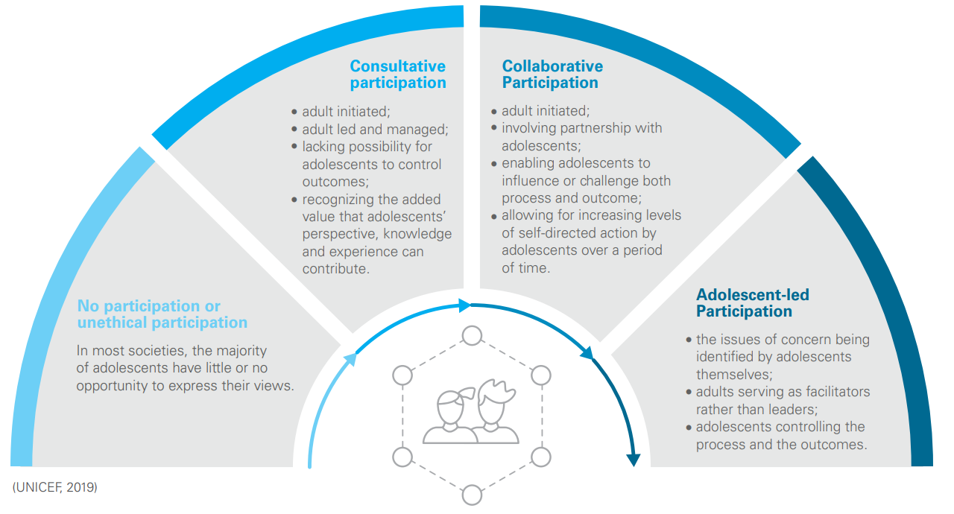
(from https://www.unicef.org/sites/default/files/2020-08/ADAP-Guidelines-for-Participation.pdf)

Engaging Girls and Young Women in Proposal Design.
Engaging GYW in proposal development stage can help set the bar for meaningful participation across the project cycle.
When we talk about girls and young women’s participation in programmes, it sometimes means that in reality we are inviting GYW to implement adult-led projects: their role may be predefined by adults and they work within a project framework designed by adults.
GYW’s early involvement can help to; position their role as central to the project, develop a programme that is truly responsive to GYW’s priorities and needs, and can include diverse and marginalized voices in the process from the outset.
There are opportunities to work with GYW in a number of ways when developing your proposal. Consider the following approaches:
1) Partner with GYW to help set the priorities and direction of the project. By identifying specific decision-making opportunities in the proposal development process, GYW can contribute to setting the strategy.
For example: Brief the GYW on the three global outcomes of the project and run a participatory session that would enable them to prioritize the outcomes most important to them. Give them the opportunity to debate the importance of the different outcomes first in order to make a fully informed decision. If you want to make it more fun, you could use a ‘clap-o-meter’ or get the GYW to cheer loudly for the issue they feel is the most important (Save the Children, 2010).

2) Engage GYW to develop the objectives and indicators of the project.
For example: ask GYW what they think would signal change or a positive impact on their and their peers’ lives as an outcome of the project and work with them to then translate this into objectives or indicators.

3) Partner with GYW to undertake initial scoping or research activities that will help to inform the proposal design.
For example: Hold a mapping workshop with GYW to identify excluded girls and young women within their communities. Based on this activity, consider collectively which group(s) they can target through the ‘Her World, Her Voice’ Project.
4) Partner with GYW to brainstorm project ideas that will contribute to achieving the project’s goals.
For example: As part of the proposal design stage, run a competition with diverse GYW to come up with ideas for projects they would run in their local communities that would contribute to the goals of the project. Explain that the winner’s projects will be written into the overall proposal to WAGGGS and will be implemented, if the grant is awarded. Consider building in a micro-project component to your ‘Her World, Her Voice’ project, where GYW, particularly those from marginalized target groups, are allocated small amounts of money to lead in delivering and monitoring of individual projects.
Principles of co-designing the UPS project proposal with GYW:
- Participation takes time, so consider what can be achieved within the application timeline and focus on targeted entry points and opportunities for GYW to contribute to the proposal development, in a way that is aligned with their existing skills, knowledge and capabilities.
- Participation in the proposal writing shouldn’t be a one-off activity, but the first step in a longer process! Through the proposal development, clearly define the proposed role of GYW within the wider project. GYW can play an active role in defining these roles.
- Feedback loops: be sure to feed back to the group on the outcomes of their participation including what was the outcome of the proposal and their future role.

After the proposal
When GYW have been actively involved in the proposal development and initial project design, they are ready and well-equipped to play meaningful role in the next stages of the project, including the implementation, monitoring and evaluation. Consider how GYW can be taking up bigger responsibilities across the project cycle and where there may be opportunity for meaningful youth-adult partnerships or even GYW stepping up to lead aspects of the project.
Here are some resources to explore other ideas and approaches to meaningful youth participation:
Save the Children (2010) Putting Children at the Centre, A practical guide to children’s participation: https://resourcecentre.savethechildren.net/node/3583/pdf/3583.pdf
Save the Children (2013) Children’s Participation in the Analysis, Planning and Design of Programmes: https://resourcecentre.savethechildren.net/node/7768/pdf/children_participation_in_programming_cycle.pdf
ActionAid (2015) ActionAid’s approach to youth programming: https://actionaid.org/sites/default/files/aa-approach-to-youth-programming.pdf.pdf
Unicef (2019) ENGAGED AND HEARD! Guidelines on Adolescent Participation and Civic Engagement:
https://www.unicef.org/sites/default/files/2020-08/ADAP-Guidelines-for-Participation.pdf

