Free Being Me – Action on Body Confidence

Young Women’s Advocacy Forum 2020
#DigitalAdvocacy during #Covid19

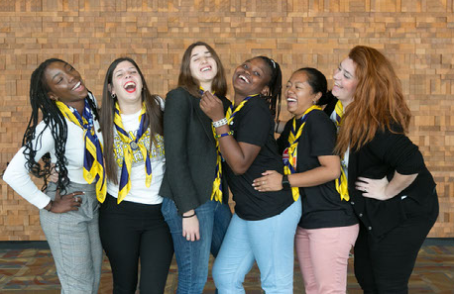
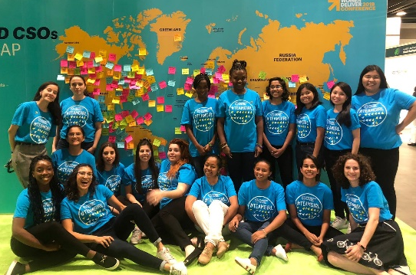

https://www.wagggs.org/en/what-we-do/young-womens-advocacy-forum-women-deliver-2019/

The Young Women’s Advocacy Forum (YWAF) is back and will be going #digital in 2020!

The Young Women’s Advocacy Forum is an initiative, which allows WAGGGS to support a network of young women who have participated in a WAGGGS programmes to focus on advocacy. Free Being Me has been delivering specialised Action on Body Confidence training for young women to launch their ABC national advocacy and gender equality campaigns since 2018.

This year marks 25 years since the Beijing Declaration and Platform for Action. The Declaration sets out key requirements and obligations for states to do more to achieve gender equality. Despite the changes to global events due to COVID19, Governments are required to make renewed commitments to Gender Equality and we are determined to provide passionate advocates and women leaders the opportunity to engage with decision makers and create revolutionary change. This year’s cohort will receive training specific to the challenges COVID19 has presented for global advocacy. In 2020, the advocacy training will empower young women to build a digital advocacy action plan and provide young women with opportunities to lobby global decision makers at the virtual UN General Assembly 2020, access to comprehensive tools for digital campaign design (including campaign film making, creating digital messages), skills development and support plans to deliver an advocacy project that is either local or national in their countries. Participants will then have an opportunity to put these skills into action and engage with key decision makers at pivotal online and in person events where global governments are present.
The Young Women’s Advocacy Forum first took place in the UN General Assembly in September 2018 and then at Women Deliver Conference in June 2019. This year’s Forum will focus on opening young women up to digital spaces at UNGA and YOUNGA forum where they can advocate and connect with global decisions makers, through an inclusive, forward-looking youth-driven dialogue live-streamed around the world with emerging VR and XR (mixed reality) technologies, YOUNGA will connect young people ages 15-30 directly with influential top decision-makers and industry leaders to co-create solutions for a
more inclusive, sustainable world. Successful applicants will also have an opportunity to play a part in the 2021 Generation Equality Forum Events.

The training and programme is for young women who are keen to make a difference through advocacy campaigning, and have a strong passion for body confidence and image discrimination advocacy. Young women are trained in the right environment to realise their innovative leadership capacities and gain the confidence to deliver strong girl-led advocacy projects, with support from WAGGGS, Dove Self-Esteem Project and their Member Organisations.

Our event objectives
- Delegates are provided with the skills, resources and support needed to develop digital advocacy project plans and lead the execution of projects
- Delegates are provided with opportunities to talk about their advocacy work with key decision makers
- Delegates are exposed to the international advocacy space and enhance their knowledge of issues of importance being discussed at Beijing+25 platforms and at other UN events
- Delegates have opportunities to practice digital networking, advocacy and communication skills at online international event
- Delegated have to opportunity to train with digital communication experts, campaigners, digital influencers and experienced gender equality experts.

Application Instructions
If you are already part of our volunteers network on Mobilize please apply following the instructions below:
- Complete the online application form https://forms.gle/MkDVnw3P83asfuPQ9
- Send a 2-minute video expressing your interest to freebeingme@wagggs.org,
- along with the MO Endorsement Form https://docs.google.com/document/d/1P37-BiqQ1fQxnsd-Hhd63A3QzFMo3vtuQhAarUdeOWg/edit?usp=sharing

If you have not joined our volunteers network yet please sign up to Mobilize first:
- First, complete mobilize sign-up here: https://www.wagggs.org/en/what-we-do/volunteer/volunteer-with-us/join-wagggs-volunteer-pool/
- then complete the online application form https://forms.gle/MkDVnw3P83asfuPQ9
- Send a 2-minute video expressing your interest to freebeingme@wagggs.org,
- along with the MO Endorsement Form https://docs.google.com/document/d/1P37-BiqQ1fQxnsd-Hhd63A3QzFMo3vtuQhAarUdeOWg/edit?usp=sharing

Please complete the online form and ensure you return the completed MO endorsement form and video to freebeingme@wagggs.org by Monday 13th July 2020.

What we offer
- Comprehensive digital training and e-learning on specialised digital advocacy – including how to communicate with and approach global decision makers, digital content creation, project development, working with policy and campaign design. Training is developed to allow young women to learn at their own pace over one month (July 2020), with group webinars where young women are able to connect with WAGGGS support and others in the movement.
- Delegate spot at inaugural YOUNGA Forum under the auspices of the UN Secretary-General's Office for Sept 28-29, 2020.
- Opportunity to speak at and facilitate digital sessions at augural YOUNGA Forum under the auspices of the UN Secretary-General's Office for Sept 28-29, 2020.
- A world class programme of filmmaking and digital communications training
- Invitations to key Generation Equality 2020 online engagements, exposure to the international advocacy online spaces and the opportunity to a build professional network.
- Potential travel to 2021 Generation Equality Events and delegate spots supported by accommodation, flights, registration fee transport and per diems.
- Support and training on effective communication, especially speech/blog writing, social media, reaching out to decision makers and public speaking and pitching.
- Regular webinars, monthly 1-1 project support and Q&As with WAGGGS staff to expand knowledge on advocacy and how to build a campaign.
- Access to Advocacy grant to support project development.
- Opportunity to be mentored and work with previous YWAF alumnae on national advocacy projects.

Applicant criteria
- Aged 18-29
- A valid passport
- Applicant must be from a Member Organisation who has delivered Free Being Me or Action on Body confidence nationally
- Experience with either Free Being Me or Action on Body Confidence programme and a clear passion of body confidence, inclusion, representation and importance of self-esteem.
- Endorsed by your Member Organisation.
- Available for online Forum trainings and activities between July – October 2020
- Actively involved in Guiding/Scouting in your community and experience working on advocacy campaigns
- Access to IT services to be able to take part in online training prior to Young Women’s Advocacy Forum
- Commitment to their advocacy project goals and communicating quarterly reporting on progress/milestones
- Confident, clear English Speaker and happy to talk in public in English
- Interested in issues related to gender, body confidence and body politics, self-esteem and mental health, nutrition and violence against women. You don’t have to be an expert but you do have to be interested in learning more
- Committed to running campaigns locally/regionally/nationally following your participation at Young Women’s Advocacy Forum

Please return your completed form to freebeingme@wagggs.org by Monday 13th July 2020. Your application is incomplete and will not be accepted if we do not receive this form.

