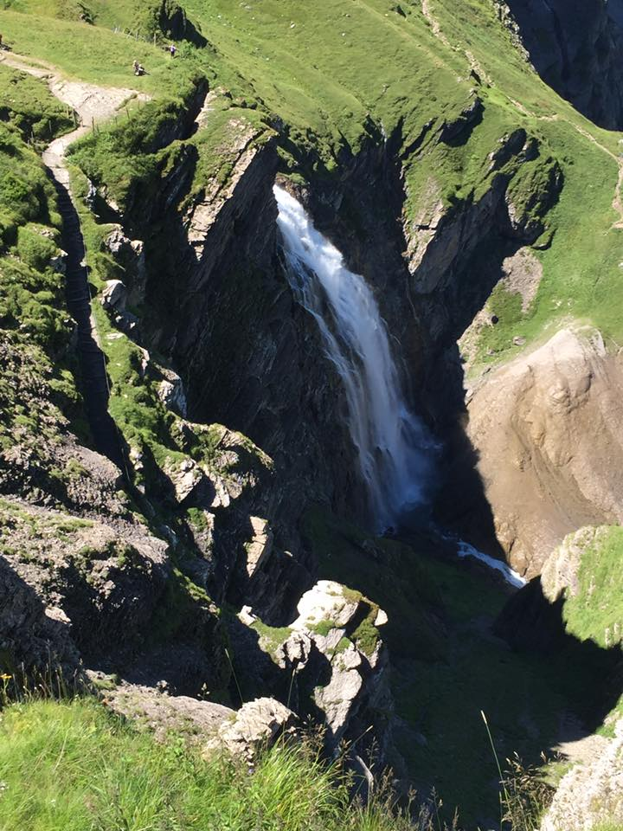

Our Chalet Mini Breaks
December 2018 – May 2019
September – October 2019

Our Chalet Mini Breaks 2019
January - May & September - October
Perfect for Guide and Scout groups and families, Our Chalet Mini Breaks have been created so you can enjoy a fun and affordable weekend away, savouring the sights and sounds of Switzerland! These package options have been tailored to best accommodate your groups age-wise and interest-wise. You will be able to discover the beauty of the mountains, try new activities, explore the outdoors, and experience the magic of an international Guide and Scout Centre. The package includes a variety of on-site activity options, a healthy snack for each full day at Our Chalet to ensure that participants have energy to enjoy the full programme days, and fun and educational challenges to spice up the hikes!

Cost
To best accommodate all groups, we have created three package options.

High season (February, May, September)
Option A: CHF 205
2 nights, Friday – Sunday
1.5 Day & 2 Evening Programmes
Option B: CHF 300
3 nights, Thursday – Sunday
2 Day & 3 Evening Programmes
Option C: CHF 300
3 nights, Friday – Monday
2 Day & 3 Evening Programmes

Low season (January, March, April, October)
Option A: CHF 165
2 nights, Friday – Sunday
1.5 Day & 2 Evening Programmes
Option B: CHF 240
3 nights, Thursday – Sunday
2 Day & 3 Evening Programmes
Option C: CHF 240
3 nights, Friday – Monday
2 Day & 3 Evening Programmes

All Our Chalet Mini Break packages include:
- Our Chalet in-house accommodation
- All meals from dinner on arrival day to lunch on departure day
- Luggage transfer on arrival and departure day (8am - 6pm)
Programme includes:
- One guided hike with optional activities for additional cost (full Programme Day)
- On-site activity day (half or full Programme Day)
- Swiss Night & Campfire Evening Programmes
- Games Evening (for groups staying 3 Evening Programmes only)
Package price does NOT include
- Personal souvenirs and snacks
- Additional taxis or buses
- Travel or health insurance
- Travel to and from your home to Our Chalet
- Use of internet and personal laundry

Booking
Please take the time to read through this Information Pack. To reserve your place, contact info@ourchalet.wagggs.org or make an on-line booking on our website at www.ourchalet.ch. We will then provide you with a booking contract and request a 10% non-refundable deposit which will secure your reservation.
Yours in Guiding and Scouting,
Your Our Chalet Team
Day Programme Descriptions
We have endeavoured to create a weekend programme package that enables your group some flexibility. For each Day Programme you will be able to choose from a selection of activities based on the age and interest of your group, which are included within the cost of the package. On the Guided Hike Day there is one activity option for an additional cost.
Below you will find an outline of the weekend programme on offer, as well as which activities apply to your package. More information on the specific activity options can be found in the next section.
Day | Day Programme | Package |  |  | Evening Programme | Package
 |  | A | B | C |  | A | B | C
Thursday | No Day Programmes |  |  |  | Games Evening |  | ●
Friday | On-Site Activity Day |  | ● |  | Swiss Night | ● | ● | ●
Saturday | Guided Hike Day | ● | ● | ● | Campfire | ● | ● | ●
Sunday | On-Site Activity Day | ●  (1/2) |  | ● | Games Evening |  |  | ●
Monday | No Day Programmes |  |  |  | No Evening Programmes
The Our Chalet Team is pleased to bring you the following activities, all of which are led by our programme and volunteer staff. Please contact the Programme Team (programme@ourchalet.wagggs.org) as soon as possible, but no later than one month prior to your arrival, to confirm which activities you and your group are interested in and to discuss how to adjust them for your age group.
On-Site Activity Day
For the On-Site Activity Day we stay largely on Our Chalet grounds. Below you will find a selection of activities ranging from traditional Scouting skills to a tour of Our Chalet and a visit to the shop. Each activity lasts approximately 1.5 hours. Please choose activities based on the appropriate age level for your group. We will start the on-site day with an official Pinning Ceremony to welcome you to the Our Chalet family.
- Half Day Programme (Package A): You will have the opportunity to choose one or two activities to do on the Sunday morning prior to your departure.
- Full Day Programme (Packages B & C): You will be able to choose four of the below activities. Two activities will be before lunch and the other two after lunch.

AVAILABLE YEAR ROUND:

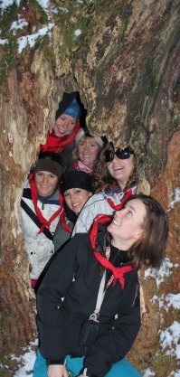
Craft & Scavenger Hunt
Make some beautiful crafts! Decorate your room with snowflakes, burn a design into a wooden peg, and learn the Swiss craft of Scherenschnitte. Afterwards, have a go at the Our Chalet scavenger hunt which sends you all around the Our Chalet grounds!

Our Chalet Tour & Shop
Learn about the history of Our Chalet with a presentation followed by a tour of the main buildings and a visit to the Shop.

Magic Tree Hike
If you are not participating in the Magic Tree Hike during your Guided Hike Day, our staff will lead you on a short hike through the forest to the 600-year-old Magic Tree. Remember to make a wish at the tree! In the winter, this activity can be done on snowshoes!
WAGGGS Wide Game
There are 10 million Girl Guides and Girl Scouts around the world. Find out what they do, what WAGGGS is doing to improve the lives of girls and young women around the globe, and what it means to be a member. Also learn more about the Five World Centres, play some interactive games and have your say on the issues girls and young women are facing today.

Introduction to Stop the Violence
Adjustable for participants of all ages!
Learn more about the WAGGGS Voices of Violence curriculum. After this session, you will understand more about the issue of violence against girls and young women, and what the World Association is doing to stop it.

Introduction to Action on Body Confidence
Best suited for participants between 10 and 16; useful also for leaders interested in the programme!
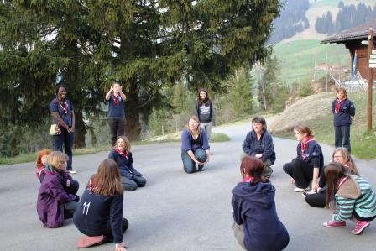
Global research has shown that 6 in 10 girls worldwide give up an activity they love because of worries about the way they look. WAGGGS has now created the next step to the ‘Free Being Me’ programme. ‘Action on Body Confidence’ not only has unique, fun and inspiring activities that help participants realise that they are beautiful just the way they are. This programme also focuses on learning about advocacy, identifying decision makers and taking action.

Outdoor Games
Play some fun games outside! Games may range from international games, to teambuilding games, to old favourites.

Campfire Building & Cooking
Practice your campfire building skills! Using a traditional Swiss method, you can try starting a fire from just a few large pieces of wood. After you have successfully started your fire, make yourself a delicious snack.

AVAILABLE IN SNOW FREE MONTHS:

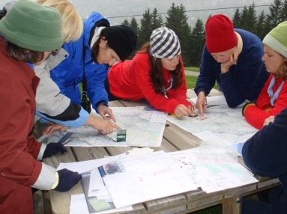
Orienteering
Learn some basics of using a map and compass and then have a go at finding different markers located around Our Chalet’s property.

Environment
During this session, you will get to visit the new Eco-Hut, play a variety of environmental games and learn more about how you can protect the planet!

AVAILABLE ONLY IN WINTER:

Sledging/Tobogganing
Want to experience the 80+ year long tradition of sledging at Our Chalet? Our grounds provide the perfect opportunity and slopes to learn the fine art of tobogganing / sledging!

Igloo Building
This is a great team building activity and is great fun! Afterwards you can enjoy your igloo, leave it for other groups, or even destroy it during a snow ball fight!

Snow Olympics
Try your hand in a variety of snow activities ranging from tobogganing to snow sculpting and snowball throwing! Our Chalet staff will tailor a fun session of snowy outdoor games that will provide challenge for all ages!

Guided Hike Day
For the Guided Hike Day, Our Chalet Staff will lead you on a full-day hike somewhere in the Adelboden Valley. You are able to choose from one of the three below hike options. The first two options are covered in the cost of all packages and based on age. The third option is suitable for all ages but comes at an additional cost and is not available for the entirety of the spring season (please see further details below).

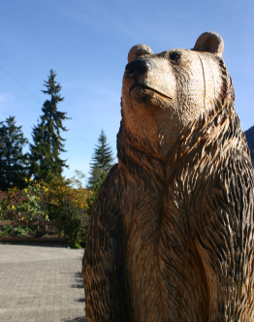
Included in package price:

Woodcarver’s Hike & Adelboden Town

(best suited for girls 11+ years)
The most famous and traditional hike from Our Chalet takes you along quiet lanes, with breath taking views of the Adelboden valley. At the Woodcarver’s workshop you can purchase and admire a range of beautiful hand-carved objects, including many items unique to Our Chalet, like wooden name badges, Guide and Scout woggles, and music boxes that play the Our Chalet song. From the Woodcarver you can walk into Adelboden Town to explore, shop, or visit the Adelboden Museum. The Adelboden Scavenger Hunt will help you notice all the fun details and learn more about the village!

Bunderfalls & Magic Tree Hike

(best suited for girls <10 years)
This walk leads you to explore the valley extending behind Our Chalet. Meet our mascot Marta Marmot and accompany her on a leisurely walk to the beautiful Bunderfalls cascading down the Lohner mountains. Fun team building challenges await you on the way before you can enjoy the fresh, cold mountain water while snacking on your packed lunch. The loop through the Magic Tree hike leads you through the woods to what is rumoured to be the oldest tree in Adelboden – the Magic Tree, at 600 years old! The trunk of this tree is completely hollowed out, so make sure you step inside and make a wish – and help Marta Marmot on her mission!

When you return to Our Chalet in the afternoon, you can either choose to rest up for the evening or let Our Chalet staff entertain you for another hour!

For an additional cost:
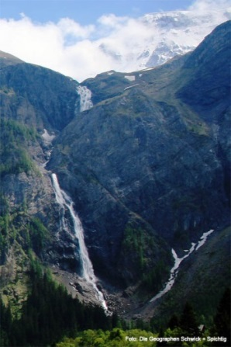
Engstligenfalls Hike & Engstligenalp Experience

(suitable for all ages, minimum of 10 participants)

Start your day with a short lesson in map and compass skills, and then take turns leading your group on a 2-hour hike to the second largest waterfall in Switzerland! You may face different obstacles and challenges along the way before you can enjoy a packed lunch or a delicious BBQ lunch around a campfire. In the afternoon, take the gondola up to Engstligenalp, a protected high alpine plateau where snow stays long into the spring season. There are fantastic views of the valley from the top of the alp as well as a variety of activities depending on weather and snow coverage, from snow tubing to geocaching to enjoying a cup of hot cocoa in a restaurant. Please note that the gondola closes in early May, so this option is only available when the gondola is running.

CHF 20 – Engstligenalp Experience only (packed lunch)

CHF 25 – Engstligenalp Experience plus BBQ lunch

You may want to consider the option of catching the public bus partway back to Our Chalet at an approximate cost of CHF 10 per person.

Evening Programmes
Games Night
Join us for an evening of games! Games Nights are special at Our Chalet, and vary from longer, strategic wide games to short, energetic and creative ones. You could be solving a mystery, going on a Scavenger Hunt, and more!
Swiss Night
It’s time to experience Swiss culture! Listen to traditional Swiss music, learn interesting facts, test your knowledge about Switzerland and celebrate with chocolate fondue! There is an additional option of having an Alphorn player for the evening, at a cost of CHF 50 per group.

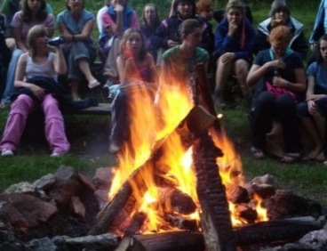
Campfire
Our Chalet international staff will run the campfire, where you’ll have a chance to learn new songs, games, dances and teach everybody some of your own favourites. At the campfire we will close the event and present badges to participants who complete the Our Chalet Challenge.

Patrol Duties
At Our Chalet, all event participants get a chance to lend a hand by participating in patrol duties. Depending on the age of the participants, you may find yourselves helping set the table for dinner or for breakfast, restocking the bathrooms with more toilet paper, or helping us with the recycling!

Our Chalet Challenge
If you feel like giving yourself the ultimate physical challenge, and would like to discover more about Our Chalet, Switzerland and WAGGGS, then the Our Chalet Challenge is for you! The Our Chalet Challenge consists of six components: Physical Challenge, WAGGGS Knowledge, Our Chalet History, Swiss Culture, Personal Challenge and Service. If you manage to complete all six sections, you will be presented with a special Our Chalet Challenge badge. The cost of the badge is included in the programme package.

Preparation and suggested packing list
Our Chalet is located in the Swiss Alps, 1353 metres above sea level, and the weather can vary greatly on a daily basis. In order to fully enjoy this programme and feel comfortable with changing weather conditions in the Alps, we advise you to be aware of this while packing, as well as build up your level of fitness prior to your arrival. You can find our suggested packing list on our website, under the Book Now, Prior to Arrival section.
Please note that throughout the year, weather conditions can vary from summery temperatures to occasional snow days!

