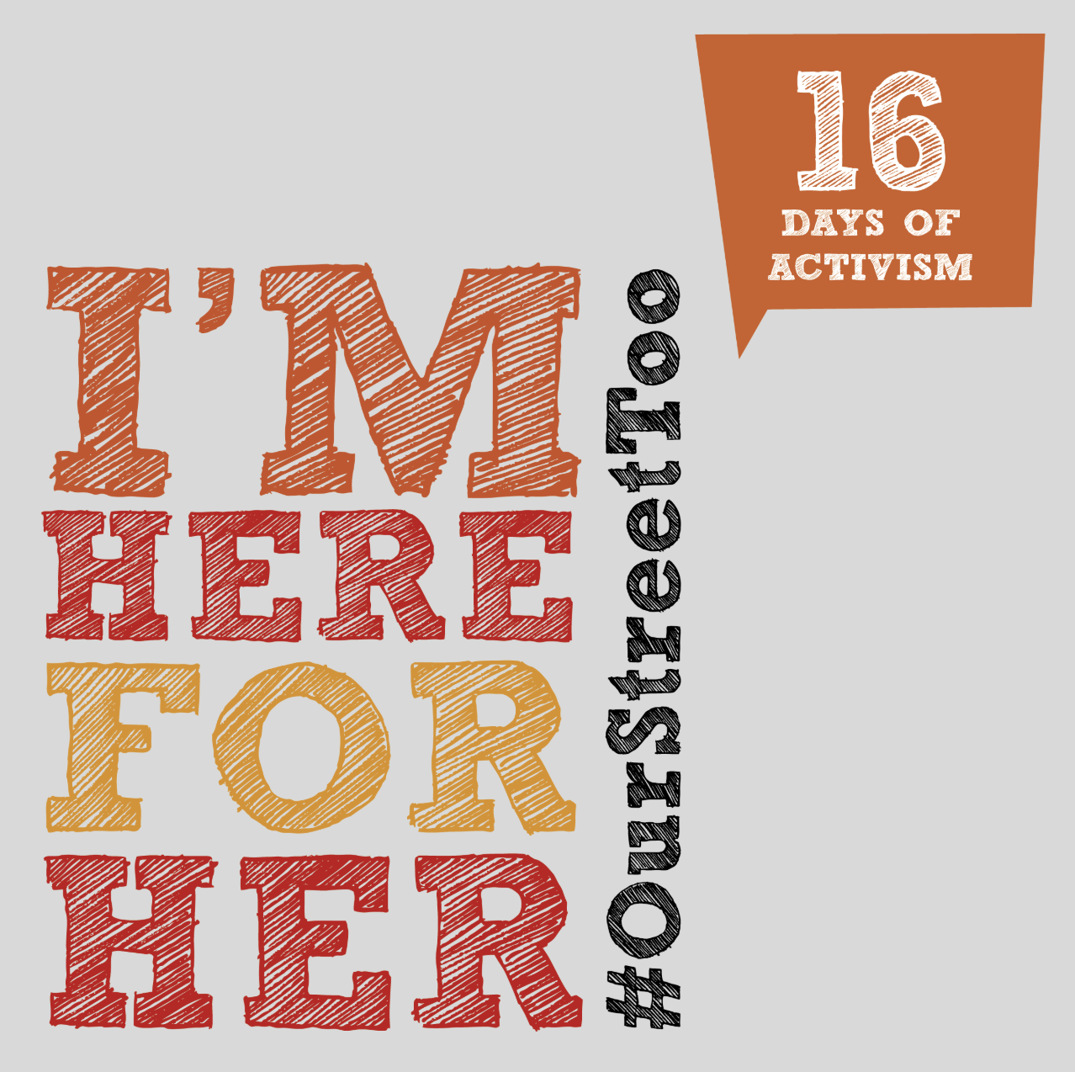
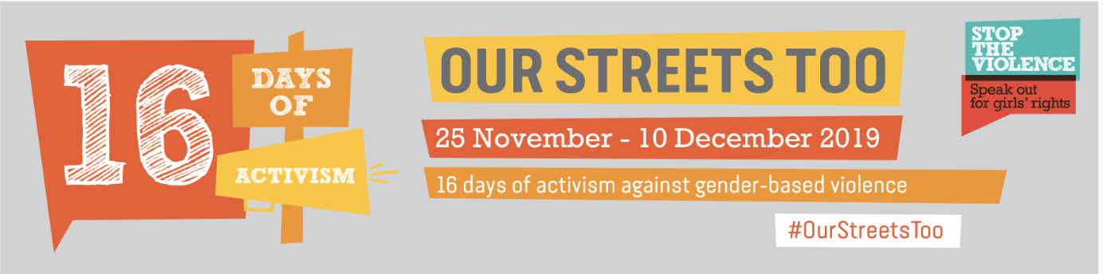
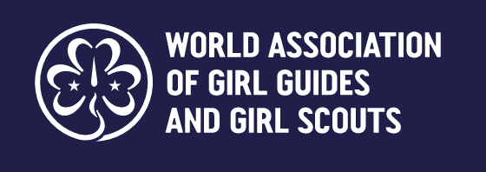

Insert MO Name, logo address
Contact information]

[INSERT DATE]

Dear [decision makers name],

We the Girl Guides and Girl Scouts of [insert Member Organisation name]
are participating in 16 Days of Activism to End Gender Based Violence, the annual global campaign to end violence against girls and women. For our campaign this year we are focusing on the harassment of girls and women in the streets of [insert country name].

On a daily basis girls and women are being harassed when they are moving through our streets. We experience harassment when travelling to and from school and work, socialising in our communities, participating in recreational activities and when simply trying to live our lives. We often have to change our routes through the streets, the modes of transport we use and avoid travelling in the dark and at different times of day to avoid the harassment we face from men and boys. We are experiencing verbal and physical harassment and abuse when we are in the streets through catcalling, inappropriate touching when we are walking through the street and on public transport. We are being followed, threatened and assaulted. The fear, worry, pain and distress we experience as a result of street harassment limit our ability to grow, thrive and reach our fullest potential. The harassment we experience in the streets is a violation of our rights! We need serious action to be taken quickly protect us.

Around the world governments are beginning to recognise that the harassment of girls and women in the streets is a crime that perpetrators should be prosecuted for. Countries including France, Chile and Georgia have now made street harassment a crime with perpetrators facing fines and imprisonment. We call on you to send a clear message to men and boys that they must stop the violence by criminalising street harassment. Girls and women cannot feel safe in a culture where impunity thrives and perpetrators are not held accountable for their actions.

Laws are not enough! We call on you to educate the men and boys of this country. They must understand that they do not have the right to harass us when we are in the streets. We as girls and women have as much right to move through the streets as boys and men, free from harm and danger. We need development that goes beyond our infrastructure but, critically, focuses on tackling the harmful social norms and stereotypes that lead to the harassment of girls and women in the streets. This is possible though education, awareness raising, community action and more.

In 2017 the World Association of Girl Guides and Girl Scouts the largest movement of girls in the world working with 10 million girls in 150 countries conducted a poll and found that of 7000 young people who responded 70% said the streets are the most unsafe place to be a girl. They received over 400 drawing from around the world in which girls depicted the violence and harassment they experience when occupying public spaces. This is unacceptable.

Goal 5 of the Global Goals for Sustainable Development calls for an end to all forms of discrimination against all women and girls everywhere in the public and private spheres. It is time to turn your commitments into action.

No girl or woman should feel unsafe or experience harassment in the streets; after all, these are our streets too.

We send you this letter in solidarity with all the girls and women of [insert country name].

From the Girl Guides and Girl Scouts of [insert name]

[Sign petition – if girls under 18 are signing the petition they can share their first name and age]

