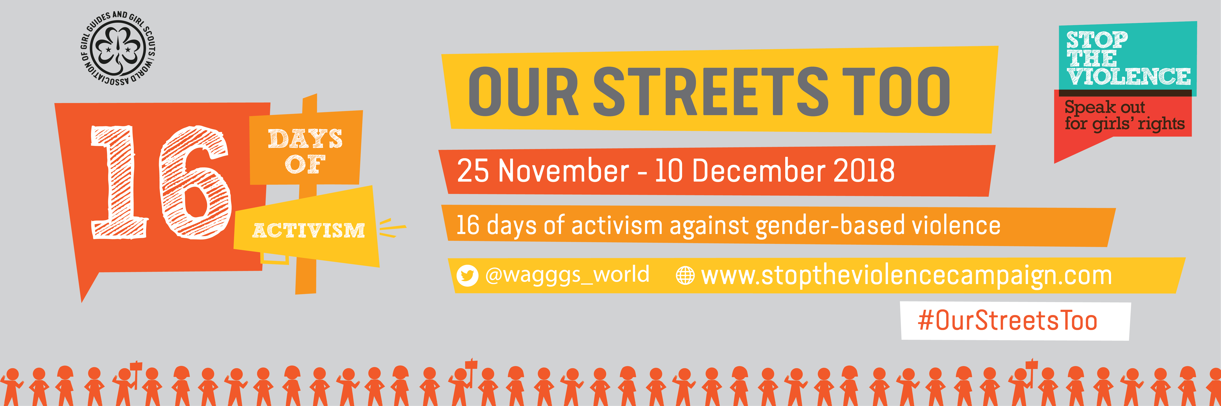
[Insert MO Name
MO address
Contact information]

World Association of Girl Guides and Girl Scouts
World Bureau, 12C Lyndhurst Road, London NW3 5PQ
www.wagggs.org

[INSERT DATE]

Dear [decision makers name],

We the Girl Guides and Girl Scouts of [insert name] call on you to support girls and women in our country by protecting us from harassment and assault in our streets. Girls and women experience harassment in the streets in a variety of ways including inappropriate touching, catcalling, leering and assault.

In 2017 the World Association of Girl Guides and Girl Scouts the largest movement of girls in the world working with 10 million girls in 150 countries conducted a poll and found that of 7000 young people who responded 70% said the streets are the most unsafe place to be a girl. They received over 400 drawing from around the world in which girls depicted the violence and harassment they experience when occupying public spaces. This is unacceptable.

We call on you to stand with the girls and women of this country by not only developing our infrastructure but, critically, focusing on tackling the harmful social norms and stereotypes that lead to the harassment of girls and women in the streets. This is possible though education, awareness raising, community action and more. We call for the criminalisation of street harassment and prosecution of perpetrators. Girls and women cannot feel safe in a culture where impunity thrives and perpetrators are not held accountable for their actions.

Goal 5 of the Global Goals for Sustainable Development calls for an end to all forms of discrimination against all women and girls everywhere in the public and private spheres. It is time to turn your commitments into action.

No girl or woman should feel unsafe or experience harassment in the streets; after all, these are our streets too.

From the Girl Guides and Girl Scouts of [insert name]

[Sign petition – if girls under 18 are signing the petition they can share their first name and age]

